

**Net Present Value (NPV)**

**Definition:** The present value of future cash flows minus initial investment costs.

**Formula:**

|  |
| --- |
| **NPV = $C_{0}+\frac{C_{1}}{{\left(1+r\right)}^{1}}+\frac{C_{2}}{{\left(1+r\right)}^{2}}+…+\frac{C_{t}}{{\left(1+r\right)}^{t}}$** |

where: $C_{0}$ 
 is initial outflow (usually investment costs, so often have negative values) $C_{t}$ 
 are net cash flows (cash flows in subsequent periods)  
r is discount rate  
t is time periof of investment

**Characteristics**: Each cash flow is discounted to the present time and then summed

**Opportunity Cost of Capital (r):** Expected rate of return given up by investing in a project

**NPV rule:** When making an investment decision, take the alternative with the highest NPV. Choosing this alternative is equivalent to receiving its NPV in cash today.

NPV > 0: The project is profitable, should be invested.

NPV = 0: The project breaks even (hòa vốn)

NPV < 0: The project is a loss, should not be invested.

|  |
| --- |
| **NPV = - PV (cost) + PV (benefits)** |

**Characteristics**: Helps to better understand cash flows, especially when doing investment analysis.

**NPV Rule and Mutually Exclusive Investments**

    *   When projects are mutually exclusive, we need to determine which projects have a positive NPV and then rank the projects to identify the best one.

    *   Pick the project with the highest NPV.

**Internal Rate of Return (IRR)**

**Definition:** IRR (tỷ lệ sinh lời mà một dự án hoặc khoản đầu tư dự kiến tạo ra) is the discount rate where NPV = 0 and is found by solving the NPV equation for the discount rate

**Economic meaning:**

* IRR is the maximum return (**mức sinh lời tối đa)** that a project can achieve without incurring a loss.
* If you invest capital at an interest rate lower than IRR, the project is profitable.

**Decision rule:**

* Accept if IRR > r (cost of capital)
* Reject if IRR < r

** IRR may be unreliable when projects have delayed investments or multiple sign changes in cash flows, leading to multiple or no IRRs

**Limitations:**

Situations in which the IRR rule and NPV rule may be in conflict:

* Delayed Investments (aka lending vs. borrowing)

* IRR rule breaks down here, as a higher discount rate could make the project look better when it actually isn't.

* Nonexistent IRR

Some cash flow patterns yield no discount rate that sets NPV to zero, leading to no IRR, thus only NPV rule applies reliably.

* Multiple IRRs

* In such cases, NPV is more reliable.

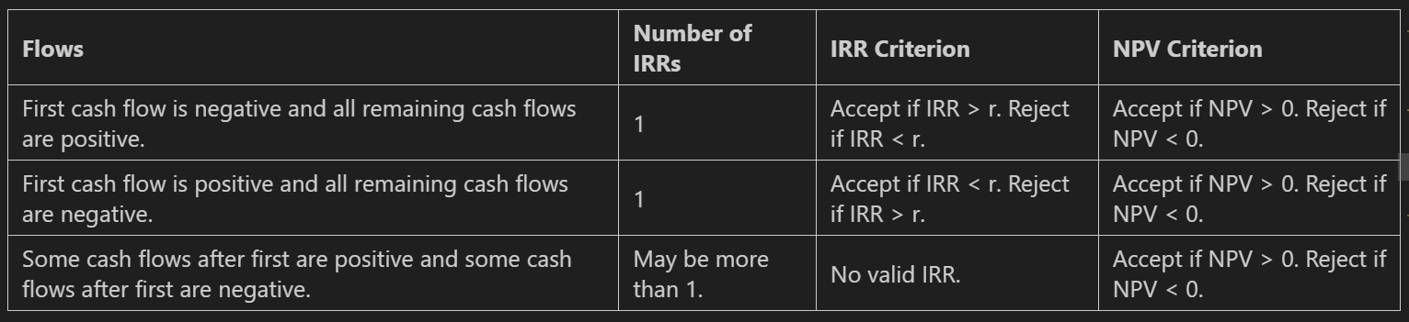

**IRR Rule and Mutually Exclusive Investments**

When projects differ in their scale of investment, the timing of their cash flows, or their riskiness, then their IRRs cannot be meaningfully compared.

* If a project has NPV > 0, then if we can double its size, its NPV will double.
* By the Law of One Price, doubling the cash flows of an investment opportunity must make it worth twice as much.
* However, the IRR is unaffected by the scale of the investment opportunity because the IRR measures the average return of the investment.

Even when projects have the same scale, the IRR may lead you to rank them incorrectly due to differences in the timing of the cash flows.

* The IRR is expressed as a return, but the dollar value of earning a given return depends on how long the return is earned.
* Even when projects have the same horizon, the pattern of cash flows over time will often differ.

An IRR that is attractive for a safe project need not be attractive for a risky project.

**The NPV Profile and IRR**

* The NPV of a project depends on the appropriate discount rate.
* There may be some uncertainty regarding the project's discount rate.
* In that case, it is helpful to compute an NPV profile.

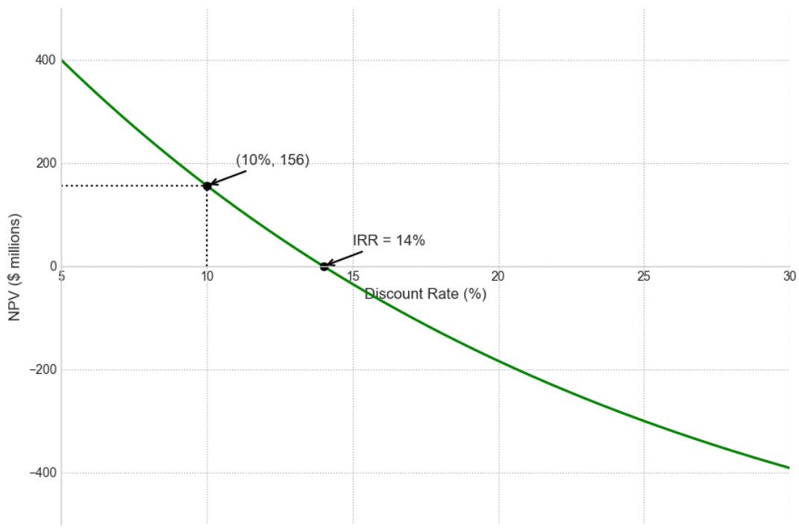

* IRR = 14%: This is the discount rate that makes NPV = 0.
* The x-axis intercept (X) gives us the IRR:

+ If cost of capital < IRR (e.g. 10%) ⇒ NPV > 0 ⇒ The project is profitable.

+ If cost of capital > IRR ⇒ NPV < 0 ⇒ The project is a loss.

* Meaning of point (10%, 156):
* When using a 10% discount rate: The project’s NPV ≈ $156 million.
* That is, if the cost of capital is 10%, you will “net” $156 million from this project.
* Shape of the curve:
* The curve slopes downward ⇒ NPV decreases as interest rates increase.
* This is normal because when the discount rate is higher, future cash flows have lower present values ​​⇒ NPV is lower.
* Interest Rate Sensitivity: The steeper the line ⇒ the more sensitive the project is to interest rates.

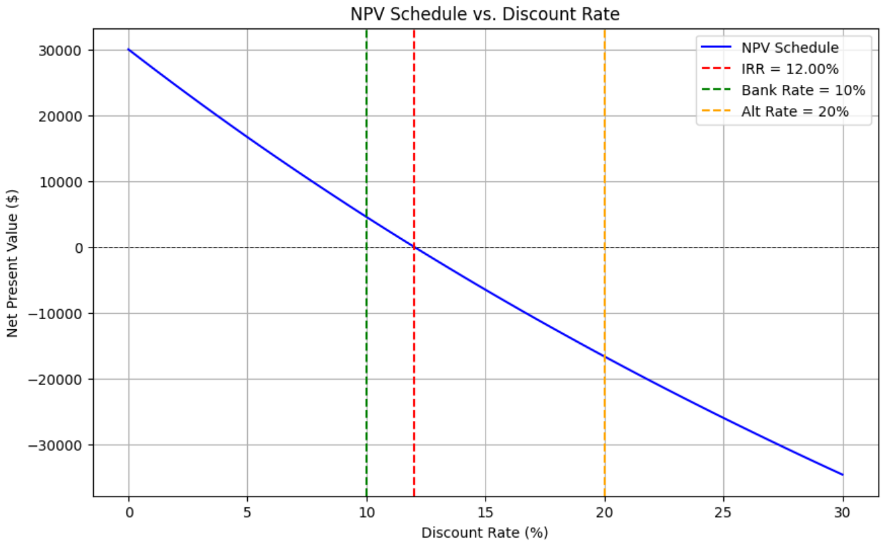

* **Blue Line (NPV Schedule)**
* Each point on the curve represents the NPV for a particular discount rate.
* The downward sloping line shows that: the higher the discount rate ⇒ the lower the NPV, because future cash flows are discounted more strongly.
* **Red Line:** IRR = 12% – the discount rate at which NPV = 0. This is the internal rate of return of the project.
* **Green Line:** Bank Rate = 10% – bank savings interest rate (an alternative to investment).
* **Orange Line:** Alt Rate = 20% – interest rate of another alternative investment (can be stocks, real estate...).
* Compare IRR and Cost of Capital:
* IRR = 12%: This is the internal rate of return of the project.
* If you discount the project cash flows at 12%, NPV = 0 ⇒ break-even.
* If Bank Rate = 10% < IRR ⇒ This project is better than depositing in the bank.
* If Alt Rate = 20% > IRR ⇒ The alternative is better ⇒ Alt should be chosen.
* Conclusion from the graph:
* If cost of capital (r) < 12% ⇒ NPV > 0 ⇒ Project is profitable.
* If cost of capital > 12% ⇒ NPV < 0 ⇒ Project is loss making ⇒ should not invest.
* This project should only be implemented if you have no investment opportunity better than IRR 12%.

**Equivalent Annual Annuity (EAA)**

**Definition:** Method used to compare projects or investments with different lifespans by converting their net present values (NPVs) into an equivalent annual cash flow.

**Purpose:** Helps compare projects with unequal lifetimes (e.g., a 3-year project vs. a 5-year project)

**Formula:**

|  |
| --- |
| $$EAA=\frac{NPV* r}{1-{\left(1+r\right)}^{-n}}$$ |

Where:

NPV = Net Present Value of the project

r = Discount rate (or cost of capital)

n = Project lifespan (in years)

**Interpretation**:

* A higher EAA means the project provides **more value per year**.
* Used in **capital budgeting** to decide between mutually exclusive projects

**Incremental IRR**

* Incremental IRR is the IRR of the difference in cash flows when switching from a smaller to a larger project; it indicates the discount rate at which switching is profitable.

**Decision rule:** accept larger project if incremental IRR exceeds cost of capital.

**Incremental IRR shares IRR rule limitations:** may not exist, multiple IRRs possible, and cost of capital comparison can be ambiguous.

**Incremental cash flows may be uneven:** Even if both projects have a normal cash flow pattern (first negative, then positive), the difference between them may not be — resulting in no IRR or more than one IRR.

**Does not assess independent value:** Incremental IRR only tells you whether switching from one project to another is profitable — not whether any project has a positive NPV.

**Unclear discount rates for comparison:** If the projects have different costs of capital, it is uncertain which rate to use to assess incremental IRR.

**Profitability Index (PI) – chỉ số lợi nhuận**

**Definition:**

* The ratio of present value of future cash flows to initial investment (NPV per unit of resource consumed).
* Measures **value created per dollar invested**.
* PI > 1.0: Project adds value (NPV > 0).



**Decision Criterion:** Select projects with higher PI when capital is limited.

**Application:** Identify the optimal combination of projects to maximize total NPV within resource constraints.

1. Compute the profitability index,
2. Rank projects based on PI value,
3. Start with the project with the highest index and move down the ranking,
4. Take all projects until the resource is consumed.

**Payback Period**

**Definition**

* Payback Period is the amount of time it takes to recover the initial investment cost, i.e. the number of years it takes for the total cash inflows to equal the investment cost.
* Payback Period = The time it takes to return the initial investment

**How to calculate Payback Period**

**Step 1:** Add up the annual cash flows

**Step 2:** Determine the first year in which the accumulated cash flows ≥ invested capital

**Step 3:** If it exceeds the level in that year → interpolate by the fifth to find the exact payback time

**Summary of Investment Rules**

|  |  |  |
| --- | --- | --- |
| **Concept** | **Definition/Rule** | **Notes** |
| **Net Present Value (NPV)** | * Present value of cash inflows minus initial outflow * Accept if NPV > 0 | Measures absolute value added; preferred decision criterion |
| **Internal Rate of Return (IRR)** | * Discount rate where NPV=0 * Accept if IRR>r (cost of capital) | May be misleading with multiple IRRs or non-standard cash flows |
| **Payback Period** | * Time to recover initial investment * Accept if within threshold | Simple but ignores time value of money and cash flows beyond payback |
| **Profitability Index (PI)** | * Ratio of NPV to investment * Ranks projects by value created per unit resource | Useful under resource constraints for project selection |
| **Equivalent Annual Annuity (EAA)** | * Annualized NPV over project lifespan * Helps compare projects with different durations | Converts NPV into comparable annual cash flow |
| **Incremental IRR** | * IRR of difference in cash flows between projects * Guides switching decisions | Subject to IRR rule limitations; must be interpreted cautiously |